**Ultrasonic Security System**

*Project report submitted in partial fulfillment of the requirements for the degree*

*of*

**BACHELOR OF VOCATION**

**IN**

**INTERNET OF THINGS**

By

**Khushi Gupta (1904701)**

**Neelu Devi (1904707)**

UNDER THE GUIDANCE OF

**Dr. R.S. PAVITHR**

DEPARTMENT OF PHYSICS AND COMPUTER SCIENCE

DAYALBAGH EDUCATIONAL INSTITUTE, AGRA

**DECLARATION**

We hereby declare that the work reported in the IOT thesis entitled **“Ultrasonic Security Sysytem”** submitted at Dayalbagh Educational Institue, Agra, is an authentic record of our work carried out under the supervision of  **Amar sir**. We have not submitted this work elsewhere for any other degree.

Khushi Gupta (1904701)

Neelu Devi (1904707)

Department of Physics and Computer Science

Dayalbagh Educational Institute, Agra

**CERTIFICATE**

This is to certify that the work reported in the IOT. thesis entitled **“Ultrasonic Security System”**, submitted by **Khushi Gupta, and Neelu Devi** at Dayalbagh Educational Institute, Agra, is a bonafide record of their original work carried out under my supervision. This work has not been submitted elsewhere for any other degree.

Dr. R.S. Pavithr

Dept. of Physics & Computer Science

**ACKNOWLEDGEMENT**

We are highly indebted to Dr. R.S. Pavithr for motivating and enlightening us for our project work. We thank you for being a constant support throughout, without whose valuable guidance and insights, this project would not be a complete one. We offer you our sincere gratitude to you for instructing and directing us through thick and thin.

Thank you for being there and helping us in and out.

**Introduction**

In this project, we are going to make a Ultrasonic Security system using [the HC-SR04 ultrasonic sensor](https://maker.pro/custom/tutorial/hc-sr04-ultrasonic-proximity-sensor-datasheet-highlights). The ultrasonic sensor used in this project is used as a distance sensor, it will tell us the distance at which the object is placed. Using this distance value, we will turn the buzzer on or off.

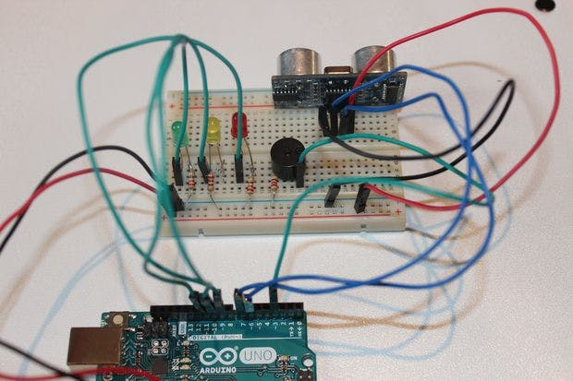

**Components Required -**

* Arduino UNO
* Breadboard
* Ultrasonic Sensor HC – SR04
* Buzzer
* Led
* Jumper Wires

**System Design Of Ultrasonic Security System -**

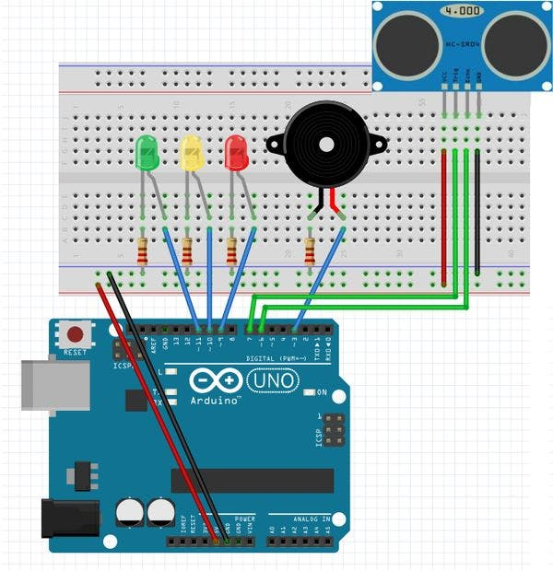

**Code of the Ultrasonic Security System –**

#define trigPin = 2

#define echoPin = 3

#define LEDlampRed = 4

#define LEDlampYellow = 5

#define LEDlampGreen = 6

#define soundbuzzer = 7

int sound = 500;

void setup() {

Serial.begin (9600);

pinMode(trigPin, OUTPUT);

pinMode(echoPin, INPUT);

pinMode(LEDlampRed, OUTPUT);

pinMode(LEDlampYellow, OUTPUT);

pinMode(LEDlampGreen, OUTPUT);

pinMode(soundbuzzer, OUTPUT);

}

void loop() {

long durationindigit, distanceincm;

digitalWrite(trigPin, LOW);

delayMicroseconds(2);

digitalWrite(trigPin, HIGH);

delayMicroseconds(10);

digitalWrite(trigPin, LOW);

duration in digit = pulseIn(echoPin, HIGH);

distance in cm = (duration in digit/5) / 29.1;

if (distanceincm < 50) {

digitalWrite(LEDlampGreen, HIGH);

}

else {

digitalWrite(LEDlampGreen, LOW);

}

if (distance < 20) {

digitalWrite(LEDlampYellow, HIGH);

}

else {

digitalWrite(LEDlampYellow,LOW);

}

if (distance < 5) {

digitalWrite(LEDlampRed, HIGH);

sound = 1000;

}

else {

digitalWrite(LEDlampRed,LOW);

}

if (distanceincm > 5 || distanceinsm <= 0){

Serial.println("Outside the permissible range of distances");

noTone(soundbuzzer);

}

else {

Serial.print(distance);

Serial.println(" cm");

tone(buzzer, sound);

}

delay(300);

}

**Applications –**

* It can used as a security system outside the doors.
* It can used in home doors.